**Software Testing :** Software Testing is a process of executing a program or application with intent of finding software bugs. It can also be stated as validating and verifying that whether a software meet its business and technical requirements or not.

**Software Testing Life Cycle (STLC):** STLC is process that is conducted in a planned and systematic manner.

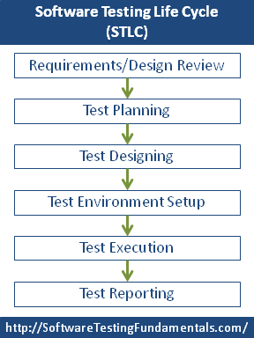

Figure : Steps Involved In STLC.

Ideally , The order of the steps is very important and should not be broken.

For Detail Understanding of each steps visit :- <http://www.softwaretestingclass.com/software-testing-life-cycle-stlc/>

[Testing in android :- <https://developer.android.com/training/testing/start/index.html>]

Android Tutorial :- <https://www.youtube.com/watch?v=bNY85mSICko>